My Philosophical Classroom:
Visual Aid: Floor Plan
Student ID: 104215014
Faculty of Education, University of Windsor
EDUC 5201: Philosophical Orientations of Education (section 10)
Professor: Dr. Vanner
November 10th, 2021

https://cloud.smartdraw.com/share.aspx/?pubDocShare=6D359FC8FE69C3032D82AC2BF3CC1006611
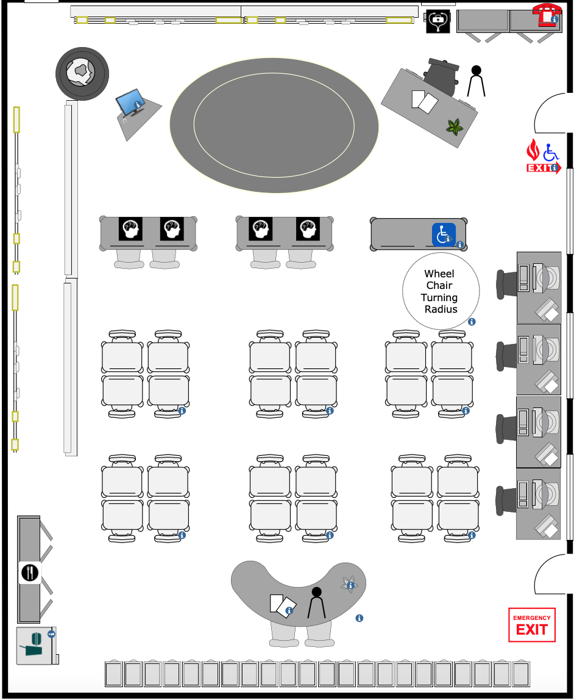

Introduction:
Welcome to my classroom! The floor plan above is designed based on a combination of several philosophical theories and concepts that have influenced and shaped my teaching values and beliefs. This essay will discuss five components that make up my ideal philosophical classroom in respect to; what one would physically see when walking into my class, how one would learn in my class, how one would know they are learning in my class, how one would feel in my class, and lastly, what one would be doing in my class. Furthermore, these components will be analysed by utilizing course concepts and theories to support the intention behind my teaching philosophy. The floor plan above will act as a visual representation of these components by reflecting the underpinnings of the philosophical concepts and theories I have adopted to shape my teaching values, beliefs, and methods. Each component will flush out the expectations of my students and of myself as an educator, in addition to a brief explanation on the factors affecting the influence on my choices. Lastly, this essay will conclude with a brief description of the feedback I received from my peers and outside perspectives that strengthened the articulation of my teaching philosophy and its practical realization.
Question 1: What would I see?
When entering my classroom, you will see tables or groupings of desks pushed together and set up around the room. Curren (2014) discusses the philosophical teaching perspective of Realism is receiving knowledge and education through experience by utilizing sensory methods. Curren (2014) inspired me to group the desks together so students can collaborate interactively and actively during lessons to aid in the sensory learning experience. Students will have assigned seating that changes monthly so children of all learning levels, cultures, genders, and ethnicities engage. Aristotle (384-322 BCE) believed education should be universal regardless of ones' socioeconomic status, race, ethnicity, gender etc. Aristotle’s belief of universal education inspired me to decorate the walls with a combination of inspirational and educational quotes addressing the importance of inclusivity, as well as symbols and images, that showcase diversity by embracing different cultures, ethnicities, races, and genders. These images will depict warmth and inspire focus to provide a sense of comfort for my students. The chalk board will have a weekly riddle written in the corner to intrigue and kickstart my students minds every Monday. My classroom rules will be established by the students at the beginning of the year, then printed out and posted on the door. There will be a snack shack in the back corner for any students that do not have a lunch. The front row of desks are free for any students struggling with learning needs or behavioural challenges and the closest desk to the teacher, and door, will be reserved for wheelchair accessibility. An additional wheelchair radius will be included for optimal accessibility as depicted in the floor plan above.
What you see sets the foundation for how you learn. The group seating suggests a lot of interactive and active learning will be occurring which will encourage peer collaboration and sensory learning in group activities. In addition, what you see and how you learn are connected to how you feel when you are in my class. By incorporating group work/activities and constantly changing the assigned seating, a sense of community amongst the students grows. A feeling of comfort, warmth, belonging and safety is developed when looking at the imagery and quotes around the room.
Question 2: How would I learn?
Active and interactive learning are two ways in which you will learn in my class. You will be physically working with manipulatives, posters, craft supplies, mixed media, and other active forms of sensory methods to experience education by seeing, touching, feeling, hearing, and tasting. For example, I will adopt a think-pair-share teaching method that appeals and accommodates different learners. The 'think' portion attributes to the individual learning experience by engaging with the course material on their own; this appeals to learners who prefer/do their best working alone (also accommodates learners who struggle socially whether that may be from anxiety or other mental health/illnesses, as well as students with behavioural problems). The 'pair' portion invites students to collaborate, communicate, and participate in any task/activity/project by actively engaging with course material and will also help you develop problem-solving skills. Lastly, the 'share' portion of this teaching method provide you with the opportunity to discuss any problem areas your group had and will also provide me with class data relating to whether the material was too challenging or too easy. Vygotsky's (1978) concept of zone of proximal development indicates students are more likely to retain information when it is presented in a pleasurable experience using sensory methods which in turn, will store the information to their long term memory. This concept has inspired me to incorporate the ‘think, pair, share’ teaching method as a form of assessment for student learning.
How you would learn sets the foundation for how you would know you’re learning and growing. First you retain the information individually, then you apply the information to the group activity. As you are doing so, you are essentially teaching others when you all present your findings to each other. The information you share may help another student in your group understand the material better and vice versa. Lastly, you get the opportunity to share with the class. This interconnects how you learn with how you know by showcasing your new-found knowledge when presenting and assessing the work you did. This also provides me with feedback on the assignment and the material I am teaching. I can collect data and determine the zone of proximity from each presentation by determining what was too challenging about the activity and what was too easy.
Question 3: How would I know?
You will know you're learning and growing by; retaining the information individually, then, you will demonstrate your knowledge by applying information to the group activity. Through the verbal application of knowledge and sharing of knowledge within your group; you are essentially teaching others when you all present your findings to each other. The information you share may help another student in your group understand the material better and vice versa. Lastly, you get the opportunity to share with the class which provides you with the opportunity to assess your knowledge on the key concepts and content within the assignment and then showcase your findings. This also provides me with feedback on the assignment and the material I am teaching. I can collect data and determine the zone of proximity from each presentation by determining what was too challenging about the activity and what was too easy. Vygotsky's (1978) concept of zone of proximal development indicates students are more likely to retain information when it is presented in a pleasurable experience using sensory methods which in turn, will store the information to their long term memory. Once again, I am utilizing Vygotsky’s (1978) concept of zone of proximal development to act as an assessment method when observing student learning.
How you would know you're learning sets the foundation for other elements such as; how you will feel, and how you would do in the class. You will feel a sense of accomplishment when completing an assignment with your fellow peers. You will feel success and confidence in yourself when you work with your peers and step outside of your comfort zone when presenting in front of the class. You will know you're learning by doing in my class. You will participate in activities and complete responsibilities in your group by collaborating with each other, as well as working on assignments as a team and as an individual.
Question 4: How would I feel?
You will feel a sense of belonging, warmth, and safety in my class. You will develop relationships with your peers that will continuously be nurtured which in turn, creates a sense of community within the classroom. Everyone is encouraged to embrace their own identities and reclaim their agency by educating each other on their different morals, values, traditions and beliefs. You will feel warmth and acceptance because culture will be celebrated and social reform will take place through the different experiences provided in the forms of activities, field trips, and class work. The snack shack will reject singling out students based on their socioeconomic status by providing all students with the feeling of care and safety in relation to having healthy appetites. By nurturing healthy appetites, healthy habits, and healthy minds; I can establish healthy learners in my class. Dewey (2009) discusses the relationship between experience and thinking. The nature of experience invokes the ways in which students think and feel about the subject matter they are learning. Learning from experience often associates learning by doing things that connect with an enjoyable experience or an experience that reflect pain. He uses the example of a child sticking their finger in a flame. The parents can tell him the flame is hot and they can burn themselves, but the information will not manifest the knowledge to reality without the child experiencing the hot flame for themselves. Thus, when the child sticks their finger in the flame, they can associate the pain with reality and commit the information into their long-term memory. A student associates feeling with learning. Once they relate to their subject material, they can develop a deeper relationship with the content.
How you feel in my classroom sets the foundation for how you learn and what you would see when you enter my class. When you walk into my classroom and see diversity and inclusion mixed with a combination of students talking and interacting with each other, you will feel a sense of belonging. As you work in a natural class community where mistakes are encouraged and voices are heard, it creates a welcoming environment that engages your need to learn.
Question 5: What would I do?
You will be asked to participate in individual and group work, in addition to completing assignments and activities by collaborating with your peers. It is your responsibility to divide up the group work fairly and communicate together with problem-solving skills and assessing each other’s work collaboratively. Williams (2017) discussed the Montessori method which adopts a play-based learning curriculum that is student-led. As I incorporate sensory methods as a form of play-based learning, I am also adopting the student-led aspect within the Montessori method to situate me as a facilitator of learning instead of a sole lecturer. Additionally, you will be encouraged to participate in presentations and physically engage in course material work on field trips and other classroom games/activities. Majority of the work will reflect a Pragmatic perspectives and Realism education based sensory model. The content will be curriculum based with real world problems incorporated. You will engage with this material through sensory methods. For example; tasting different cultural foods, actively participating in different cultural traditions such as games or playing an instrument. Curren (2014) incorporates the sensory method to learning in relation to Realism and discusses the benefits of collecting knowledge through experience by seeing, feeling, smelling, hearing, and tasting.
What you would do in my class is reflected in the ways in which you know you’re learning. By doing activities and participating, collaborating, and completing assignments; you will know that you're learning by physically experiencing the material and applying it to your own reality.
Conclusion: Peer Feedback
The feedback I received from my peers and outside perspectives that strengthened the articulation of my teaching philosophy and its practical realization included; to add an artistic element, to incorporate wheelchair accessibility, to focus on integrating accommodations for students with learning needs or challenges, and to describe my artistic element in an essay model. I attempted to incorporate every aspect provided to me by my peers and outside perspectives by searching for websites and apps that allow me to design a classroom. Initially, I had a 3D wall-by-wall visual in mind but then found a website that had several templates for building floor plans. The idea of a floor plan inspired me to utilize an aerial view and implement symbols that might be found around a classroom such as; food symbol for the snack shack, medical aid symbol for the first aid kit, emergency exit in case of a fire, wheelchair symbol to represent accommodations, and brain symbols to represent priority seating for students with learning needs/challenges and behavioural struggles. A main source that open my mind to learning challenges was my aunt that happens to be a teacher. Her perspective was a valuable source when bringing my philosophical classroom to life by adopting a realistic approach. She challenged my approaches and questioned the practicality of my methods which shaped my final perspective.
Although my philosophical classroom is not designed strictly to one philosophical theory, I have pulled specific methods, values, and beliefs from several theorists to structure what my classroom will look like. Overall, this essay analysed the five components that make up my ideal philosophical classroom in respect to; what one would physically see when walking into my class, how one would learn in my class, how one would know they are learning in my class, how one would feel in my class, and lastly, what one would be doing in my class.

References:

Curren, R. (2014). Aristotle. In D. Phillips (Ed.), Encyclopedia of educational theory and
philosophy (Vol. 1, pp. 56–59). SAGE Publications. https://www-doiorg.ledproxy2.uwindsor.ca/10.4135/9781483346229.n28
Dewey, Jin Democracy and Education An Introduction to the Philosophy of Education by
Dewey, John.S.l The Floating Press2009139 - 151
Shabani, K., Khatib, M., & Ebadi, S. (2010). Vygotsky’s Zone of Proximal Development: Instructional Implications and Teachers’ Professional Development. English Language Teaching, 3(4). https://doi.org/10.5539/elt.v3n4p237
Thomas, D. (2019, June 7th). Realistic teacher. Educational Research Techniques.
https://educationalresearchtechniques.com/2019/06/07/realistic-teacher/
Williams, Morgan K. Journal of Inquiry and Action in Education9(1)2017/00/0091 - 102

