If You Want a Marriage of Equals, Then Date as Equals

Why are many dating practices a throwback to an earlier era?

By [Ellen Lamont](https://www.theatlantic.com/author/ellen-lamont/)

FEBRUARY 14, 2020

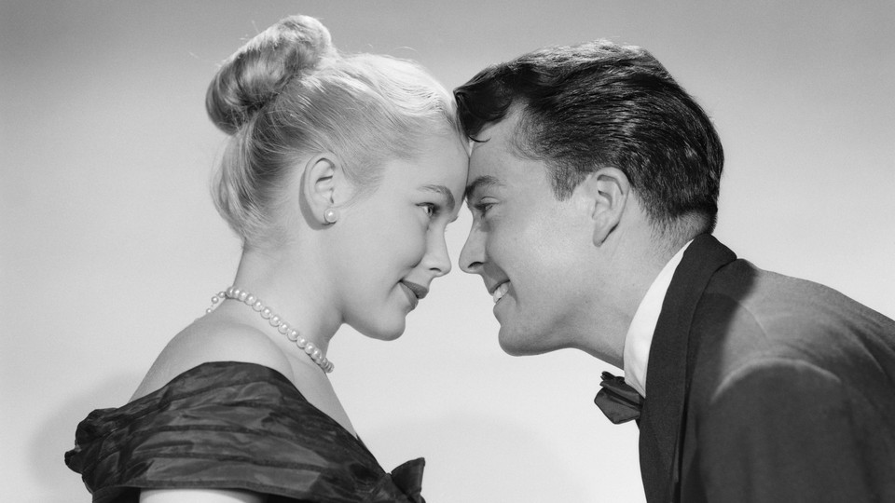

Heterosexual women of a progressive bent often say they want equal partnerships with men. But dating is a different story entirely. The women I interviewed for a research project and book expected men to ask for, plan, and pay for dates; initiate sex; confirm the exclusivity of a relationship; and propose marriage. After setting all of those precedents, these women then wanted a marriage in which they shared the financial responsibilities, housework, and child care relatively equally. Almost none of my interviewees saw these dating practices as a threat to their feminist credentials or to their desire for egalitarian marriages. But they were wrong.

As a feminist sociologist, I’ve long been interested in how gender influences our behavior in romantic relationships. I was aware of [the research](https://journals.sagepub.com/doi/10.1177/0891243210361475) that showed greater gains in gender equality at work than at home. Curious to explore some of the reasons behind these numbers, I spent the past several years talking with people about their dating lives and what they wanted from their marriages and partnerships. The heterosexual and LGBTQ people I interviewed—more than 100 in total—were highly educated, professional-track young adults who lived in the greater San Francisco Bay Area. This was not a cross section of America, for certain, but I did expect to hear progressive views. Most wanted equal partnerships where they could share both financial and family responsibilities. Almost everyone I interviewed was quite vocal in their support of gender equality and didn’t shy away from the feminist label.

However, I noticed a glaring disconnect between the straight women’s views on marriage and their thoughts on dating. Once these women were married, it was difficult to right the ship, so to speak. The same gender stereotypes that they adopted while dating played out in their long-term partnerships.

1. [Three-quarters of Millennials](https://www.nytimes.com/2018/12/03/upshot/americans-value-equality-at-work-more-than-equality-at-home.html) in America support gender equality at work and home and agree that the ideal marriage is [an equitable one](https://www.nytimes.com/2013/02/17/opinion/sunday/why-gender-equality-stalled.html). Consequently, I expected the young women I interviewed to epitomize feminist liberation. Yet, when they thought of equality among men and women, they focused more on professional opportunities than interpersonal dynamics. Americans with a college education [now get married](https://ifstudies.org/blog/early-marriage-has-fallen-especially-among-those-without-a-college-degree) in their early 30s on average, as young adults put their love life on hold while they invest in their education and establish a career. Given the significant time, money, and effort they put into building this career, the women I spoke with expected to partner with people who would support their ambitious professional goals. The men said they desired and respected these independent, high-achieving women and actually saw them as more compatible partners as a result.
2. And yet in a throwback to an earlier era, many women I spoke with enacted strict dating rules. “It’s a deal breaker if a man doesn’t pay for a date,” one woman, aged 29, told me. A 31-year-old said that if a man doesn’t pay, “they just probably don’t like you very much.” A lot of men, they assumed, were looking for nothing more than a quick hookup, so some of these dating rituals were tests to see whether the man was truly interested in a commitment. A third woman, also 31, told me, “I feel like men need to feel like they are in control, and if you ask them out, you end up looking desperate and it’s a turnoff to them.”

On dates, the women talked about acting demure, and allowing men to do more of the talking. Women, they said, were more attractive to men when they appeared unattainable, so women preferred for the men to follow up after a date. None of the women considered proposing marriage; that was the man’s job. “I know it feels counterintuitive … I’m a feminist,” the first woman said. “But I like to have a guy be chivalrous.”

1. Not all of the heterosexual women I spoke with felt strongly about these dating rules. “Getting married and having kids were probably, if they were even on the list, like number 99 and 100 on the list of 100,” one told me. “I think the men I was with knew. It would just be ridiculous if they were on a bended knee offering me a ring.” Yet even the few women who fell into this category tended to go along with traditional dating rituals anyway, arguing that the men they dated wanted them and the women “just didn’t care enough” to challenge the status quo.
2. The heterosexual men I interviewed claimed that a woman’s assertiveness took the pressure off them. While some liked paying for dates, feeling that the gesture was a nice way to show they cared, others were more resistant. One man told me he splits the cost of a date “Fifty-fifty. That goes right in line with my theory of the person I consider my equal. Just because I carry the penis does not mean that I need to buy your food for you. You’re a woman, you’re educated or want to be educated, you want to be independent—take your stance.”

But as the relationship progressed, the men I spoke with held persistent double standards. They expected women to walk a fine line between enough and too much sexual experience. They admitted to running into conflicts with “strong-willed” women. Men also wanted to be taller, stronger, and more masculine than their partners. And many of the men expected women to take their last names after marriage.

1. When men and women endorsed these traditional gender roles early in a relationship, undoing those views in marriage was difficult. The married men I interviewed often left caregiving and housework to the women, while the husbands considered themselves breadwinners and decision makers. This behavior fell in line with national trends. As [American time-use surveys](https://www.pewsocialtrends.org/2013/03/14/chapter-6-time-in-work-and-leisure-patterns-by-gender-and-family-structure/) show, women still do about twice as much unpaid labor in the home as men.

One woman said of her husband, “He’ll take our son on bike rides with him. But in the middle of the night, I’m the one getting up. Like for me to be out like this on this interview, I had to make sure there was dinner stuff for him.”

A man expressed his resentment at not having an egalitarian relationship, saying, “That’s not the relationship I want for myself.” Yet he later added that his partner should do more of the household labor, because she was more invested in a clean house.

1. The LGBTQ people I interviewed offered a different partnership model. They wanted no part of the dating scripts they saw as connected to gender inequality. “We have explicitly said we’re not normal or traditional, so we can write the script ourselves. We don’t have to buy into this belief that the guy is gonna be kinda dopey, but well meaning, and enjoy sports, and the woman is gonna withhold sex and demand to have things paid for,” one woman told me.

Because many LGBTQ relationships do not rely on well-established ideologies, norms are often considered, questioned, and then rejected, with the aim of making space for egalitarian practices instead. In the process, many of the couples I spoke with incorporated the elements they felt were important to a successful relationship, emphasizing constant communication, evaluation, and negotiation. The goal was greater individuality and equality, and they actively worked to balance their own needs with the needs of their partners. As the woman above said, “Let’s craft our own relationship.”

Just as noteworthy, the LGBTQ interviewees set up the expectations of equality from the outset of dating, not *after* it. This approach shifted their understanding of what was possible for intimate relationships, and they, for the most part, had more equal, long-term relationships as a result.