Grade: 1

Topic/Big Idea: Introduction to Fractions pt.1
Curriculum Expectations: List overall and specific expectations that you are addressing and assessing.
Overall Expectations
B: Number
B1- Number Sense: demonstrate an understanding of numbers and make connections to the way numbers are used in everyday life

B1.6- use drawings to represent and solve fair-share problems that involve 2 and 4 sharers, respectively, and have remainders of 1 or 2

B1.7: recognize that one half and two fourths of the same whole are equal, in fair-sharing contexts

B1.8: use drawings to compare and order unit fractions representing the individual portions that result when a whole is shared by different numbers of sharers, up to a maximum of 10

Learning Goals: State learning goals in direct, explicit, student-friendly language.
We are learning to:
- Understand a fraction is part of a whole
- 2 equal haves make up a whole
Materials: List all materials required by the teacher and the student for the lesson. Consider tech needs.
Google slides Presentation:
https://docs.google.com/presentation/d/1903T6ExM2I9rRJglYhRSsNkHhrWMMMSj8JNzWo_Bqw0/edit?usp=sharing

Worksheet: 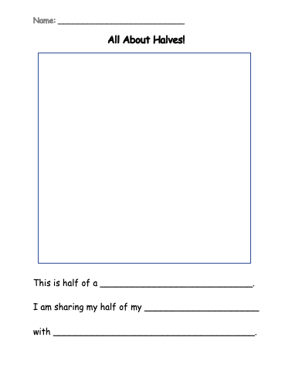

Shape cut out for cut and paste activity:


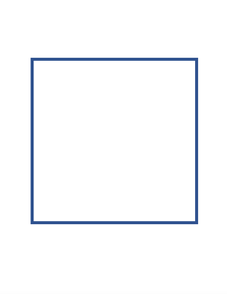

Assessment For…
Students will be asked questions during the lesson (what other halves can you think of…what does equal mean? Etc.) This will help gauge their understanding during the lesson.
Assessment As…
All about halves cut and paste activity: This activity is meant to assess students understanding of halves (there are two equal parts in a half that make a whole. Halves are EQUAL parts of a fraction.

Assessment Success Criteria (what will students be able to demonstrate by the end of the lesson?)  By the end of math, I can understand…  - A fraction is part of a whole  - 2 equal haves make up a whole | Assessment Tool(s): (i.e., checklist, rubric, , anecdotal notes, photos)  Observations, anecdotal notes
Minds On: Activating Prior Knowledge
(Establish a positive learning environment, connecting to prior learning or experiences, setting the context for learning)
How am I going to introduce the topic and motivate students to want to learn what I am teaching?
Include essential questions (open-ended guiding questions to promote thinking)

Today we are going to be making a pizza from wherever your favourite pizza place is. Stand up!
- Grab a bowl and add your ingredients: flour, salt, yeast, water, oil
- Pour it all into the bowl
- Mix it all into the bowl
- Flour your work surface
- Knead the dough
- Make it into a pizza shape (roll it, throw it into the air, etc.)
- Put it on a sheet, and add sauce and cheese

Action: (Introducing new learning or extending/reinforcing prior learning, providing opportunities for practice and application for learning)
Include essential questions you will ask students (open-ended guiding questions to promote deeper thinking)
What students need accommodations/modifications?

We have a WHOLE pizza here. Why is it a WHOLE pizza? There are no pieces missing, we are talking about th entire thing. We have the WHOLE thing.
When we talk about a WHOLE part of something, we think about the entire thing. A whole cookie, a whole chocolate bar. What other things could we call a whole?

Slide 5- So, I have a whole pizza all to myself, but now I must share my pizza. The only problem is, I only like cheese, and the person I am sharing with likes pepperoni AND cheese. What should we do? Talk to your elbow partner.

Things to look out for:
- Use of the word HALVES, EQUAL, PART, TWO

We can divide the pizza in half. We can add half pepperoni to one side, and half veggies to the other!

HALVES- are two equal parts that make up a whole.
Slide 6- play around with the line and the pizza. What is half? How do we know it is equal?
Slide 7- show examples of shapes that are cut in half AND things in real life that are split in half.

Consolidation:

The consolidation of this lesson will be all about halves worksheet, where students will fold, cut, and paste their shapes onto a page and write about their halves (Half a pizza, half a cookie, half a donut, half a cake, etc.)
This consolidation is aimed to have some hands-on activity to go with the lesson.
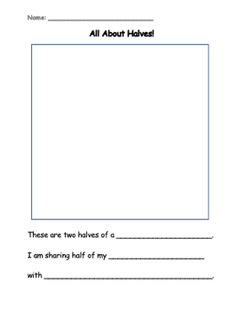
I will model the activity before, and then have students do it on their own. Students may need help with the bottom questions, but literacy is not the focus. Making sure they are understanding halves, how to make them is.

