Grade: 1
Topic/Big Idea: FRACTION INTRODUCTION PT. 2
Curriculum Expectations: List overall and specific expectations that you are addressing and assessing.
B. Number

B1- Number Sense: demonstrate an understanding of numbers and make connections to the way numbers are used in everyday life

Specific Expectations

B1.6- use drawings to represent and solve fair-share problems that involve 2 and 4 sharers, respectively, and have remainders of 1 or 2

B1.7: recognize that one half and two fourths of the same whole are equal, in fair-sharing contexts

B1.8: use drawings to compare and order unit fractions representing the individual portions that result when a whole is shared by different numbers of sharers, up to a maximum of 10

Learning Goals: State learning goals in direct, explicit, student-friendly language.
We are learning to:
- Identify wholes, halves, and quarters
- Understand that 2 quarters and 1 half are equal

Materials: List all materials required by the teacher and the student for the lesson. Consider tech needs.
Google slides presentation:
https://docs.google.com/presentation/d/1903T6ExM2I9rRJglYhRSsNkHhrWMMMSj8JNzWo_Bqw0/edit?usp=sharing

All about Fourths Worksheet:

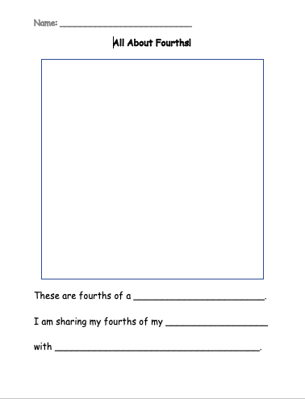

If finished: work on colour the fraction worksheet:
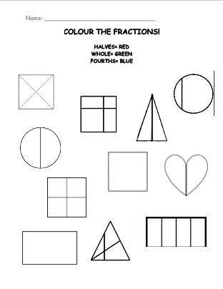
Assessment for,
Through the review of equal halves and unequal fractions (using the chart on slide18), I will be able to assess where students are in terms of recognizing fair sharing in terms of fractions. I will call students up to the board so they can point and drag the shape into the section that it belongs and ask the class if they agree.
Assessment as
Using all about fourths worksheet, students will be able to apply their learning of fourths, and physically create their own fourths and paste it onto a sheet. Students will then write about what their fourth is, and who they are sharing it with (make sure they are writing 3 names if they want to be included, or four names if they are giving it to someone.
Assessment of learning
See addendum for further information
Assessment Success Criteria (what will students be able to demonstrate by the end of the lesson?)  I will be able to…  - Recognize the difference between wholes, halves, and fourths  - Understand that 2 fourths and 1 half are equal | Assessment Tool(s): (i.e., checklist, rubric, , anecdotal notes, photos)
Minds On: Activating Prior Knowledge
(Establish a positive learning environment, connecting to prior learning or experiences, setting the context for learning)
How am I going to introduce the topic and motivate students to want to learn what I am teaching?
Include essential questions (open-ended guiding questions to promote thinking)

Review with slide number 14 (equal halves and non-equal fractions)
- If students are confused ask the question, if this was a (insert food) and you were sharing with someone (halves) would it be fair if you had this fraction, and they had this fraction.
- Looking for them to use the words equal, fair, sharing)

Give them each a printout of a KitKat bar. Give to each of the groups and ask the question “If I gave each group one KitKat bar, how would you split it between you all EQUALLY”. The students would talk to their group for about 2-3 minutes. 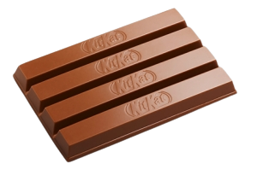

Look out for the words/ideas:
- Four pieces
- Each get four pieces
- Equal
- Fair, share

Students will discuss what they would do to share the KitKat.
(For fraction Lesson 3, I would give them the same problem but with 2 KitKats and focus on the group with 5 people. How would they share the chocolate equally, how many kit kat’s would they need? Would there be any leftovers?

Action: (Introducing new learning or extending/reinforcing prior learning, providing opportunities for practice and application for learning)
Include essential questions you will ask students (open-ended guiding questions to promote deeper thinking)
What students need accommodations/modifications?

Students will be introduced to fourths using slide number 18. “We have one whole pizza here, and we need to share all the pizza equally between 4 people. How can we make sure everyone gets a slice of pizza?
All the people like different toppings. Bruno likes Pepperoni, Isabella likes pineapple, Maribel likes mushrooms, and Antonio likes plain cheese. How can we make everyone happy?”

I will then show students examples of fourths in shapes, and in real life objects.
- Be sure to emphasis FOURths (means four)

SLIDE 24- point to the fraction and have students tell you if it is a WHOLE, HALF, or FOURTH

Introduce writing fractions using the fraction bar (line between numbers, e.g., ¼)
How many of the smiley faces are YELLOW/GREEN? More questions are located on the slides.

Consolidation:
(Helping students demonstrate what they have learned, providing opportunities for consolidation and reflection)
How will I conclude the lesson and engage my students in making final connections in their learning? (This could involve student sharing or a class discussion about what they learned, for example)

Include essential questions (open-ended guiding questions to promote deeper thinking)

Cut and Paste activity (All About Fourths)
- Students will cut out the shapes, and fold and cut their shapes into fourths.
- They will then glue their shapes onto the page, and decorate their shape into fourths of anything they want (pizza, sandwich, donut, etc.)


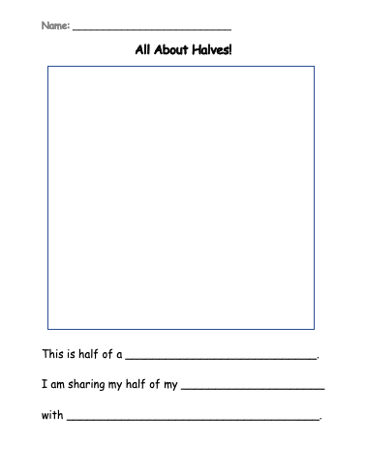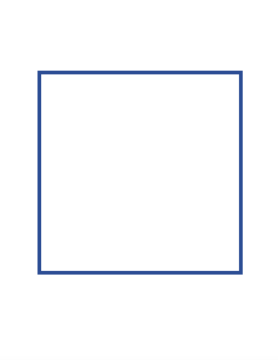

If students finish their cut and paste activity: they can work on the colour the fraction worksheet.

