|  |  |
| --- | --- |
| Lesson Plan Information | |
| Name: Marta Sokol | Date: Dec 5-6, 2022 |
| Grade Level: Grade 3 | Subject/Course: Math |
| Topic: 3D Shapes | Time Frame: 50 minutes |

|  |
| --- |
| Ontario Curriculum Expectations: |
| Overall Expectations:  E1. Geometric and Spatial Reasoning  Describe and represent shape, location, and movement by applying geometric properties and spatial relationships in order to navigate the world around them  Specific Expectations:  E1.1 Geometric Reasoning  Sort, construct, and identify cubes, prisms, cylinders, and cones by comparing their faces, edges, vertices, and angles  Learning Skills/Success Criteria:  Learning goal: I can describe things that are always true for a kind of 3-D object. I can describe things that are true for only some objects of that kind. I can build with objects.   |  |  | | --- | --- | | **1.** | I build a neighbourhood with 3-D objects. | | **2.** | I tell why I put the objects where I did. |  |  |  | | --- | --- | | **3.** | I describe the objects I use, including their faces. | |

|  |
| --- |
| Prior Knowledge and Accommodations/Modifications |

|  |  |
| --- | --- |
| Prior Learning | Accommodations/Modifications |
| In Grades 1 and 2 students will have learned about comparing 2D shapes and 3D objects and have an understanding that 3-dimensional objects have height, width and depth. It is also important for students to understand that objects can be defined based on multiple attributes. Students should have some familiarity with common 3D objects and their names (cube, sphere, cylinder, pyramid, etc). | Anchor charts explaining attributes of geometric 3D shapes.  Worksheet has a modification for students to refer to on 3D shapes if they do not know their 3D shapes yet.  I will modify time if students are engaged or need more time to complete the assigned task. |

|  |
| --- |
| Required Resources/Materials |

* Classroom 3D shapes manipulatives
* 2D shape manipulatives
* Home 3D shapes (3 cylinders (cans, paper towel roll), 3 rectangular prism (cereal box, tea box, card box), 2 cubes (box, dice), sphere (ball, marbles), cone (party hat, ice cream cone), 1 triangular prism (Toblerone box)
* Anchor chart on 3D shapes: what is a face, edge, vertices?
* 3D shape chart on attributes (face, edge, vertices)
* 3D shape hunt diagnostic worksheet
* YouTube video song on 3D Shapes: https://www.youtube.com/watch?v=ZnZYK83utu0

|  |
| --- |
| Content and Teaching Strategies |

1. Overview/Agenda/Review

I will greet students in the morning by stating the date and explaining the schedule for the day. I will instruct that students take out their agenda’s. I will look for any parental notes, forms, and initial their agenda.

On Monday, before 3D shape lesson is introduced students will be engaged in a math game for 10 minutes. The math game that students will play is place number war with cards and place mat.

On Tuesday, students engage in a math talk for 10 minutes before 3D shape lesson on geometric attributes. Math talk question on How many burgers?

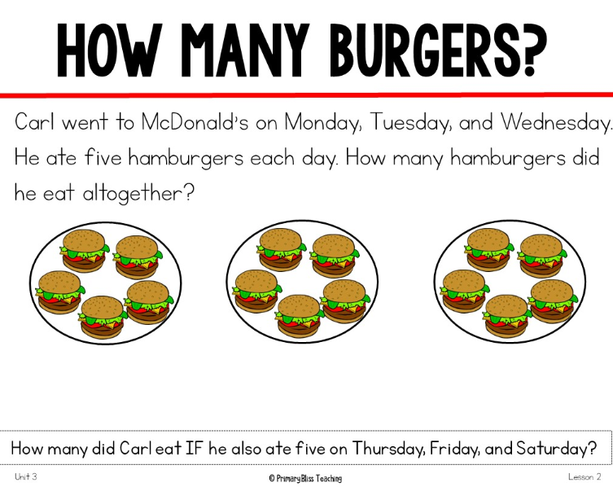

1. Introduction

Monday - Students will be instructed to come to the carpet. I will have a mystery bag filled with materials with 3D shapes. Students will use their prior knowledge to identify and describe 2D and 3D shapes that are familiar to them. How do you know that this is a 2D shape and this is a 3D shape? What does 2D and 3D mean? What is different and what is the same? I will pull out 3D shapes that are familiar to students that they would see at home. As a class I will have them group the home 3D objects with the 3D shape manipulatives. As students group the shapes, I will ask questions such as why did you pick that object for that shape? What is the same between these two shapes? I will be looking for students’ math vocabulary (face, edge, vertices/corner/point) as they example the shapes. I will be also assessing students’ knowledge on students are able to understand how 3D shapes are composed with 2D shapes (e.g., cube has 6 squares to make it a cube).

Tuesday – 3D shape song will be introduced to the students.

Students will learn about…

* + an attribute of a 3D object (face, edge, vertices)
  + a property of a 3D object
    - Some geometric attributes are called properties. They are attributes that are true for every example of that kind of object. For example, a property of prisms is that there are two identical bases joined by rectangular faces. A property of pyramids is that all the faces ither than the base meet at a point at the top and all those faces are triangles. A property of cubes is that there are six identical square faces.
    - Students will learn about congruent objects
  + describing 3D objects.
    - Students will talk about a real object it is like and they can describe attributes such as whether it rolls, the number and shapes of it faces, whether all the faces are the same, whether there are very pointed parts, etc.

As a whole group students will receive a 3D shape and I will instruct them to inspect/look at their 3D shape for how many faces, how many edges, how many vertices/ corners/ points. As a class, we will fill in a chart on how many faces, edges and vertices on each 3D shape (i.e. cube, prism, cone, pyramid, sphere, triangular prism).

1. Instructional Strategies

Monday – Diagnostic task on 3D shapes

Students will use their 3D shape hunt worksheet to look for objects that represent 3 shapes on their sheet. (eg. Cube, cylinder, prism, pyramid, etc).

Tuesday – Building a neighbourhood with 3D shapes

Students will be instructed to work in their table groups and design a neighbourhood with 3D shapes. Each table will receive their own bin full of 3D shapes. I will ask students if they know what a neighbour is and what is included in a neighbourhood. As a group we can brainstorm with 3D shape on how we would build a house. What shapes would we use to build a place where we live? (house: cube and square base pyramid, apartment: standing rectangular prism).

Build a neighbourhood with your 3-D objects. Make sure some objects are put together to make new objects. Tell why you put the objects where you did. Describe the objects you used. Make sure to describe their faces. Tell if there are any congruent objects, faces, edges, or angles.

1. Consolidation/Check for Understanding

Monday - Students will be instructed to return back onto the carpet for 5 minutes. I will ask students to share they type of 3D shapes that they found in the classroom. Have them example what made them chose that object to represent the 3D shape. I will check to see if students are using math vocabulary with words like faces, edges, and vertices. As well I will check for students understanding between 2D and 3D shapes by the objects they choose. We will discuss the shapes that were easy and shapes that were difficult to find.

Tuesday- I will circulate the classroom by observing students’ participation in their groups. As well I will observe and assess 4-5 students on their knowledge and understanding of the attributes of 3D shapes.

1. Extension

The next lessons in 3D shapes for grade 3 will focus on the learning goal I can describe ways to sort 3-D objects, and I can sort them.

|  |
| --- |
| Assessment and Evaluation |

Monday: 3D shape hunt

I will evaluate students understanding on 3D shapes through their 3D shape hunt worksheet.

Tuesday: Building with 3D shapes

I will evaluate students understanding on 3D shapes by circulating the classroom. I will observe and assess 4-5 students their knowledge through assessment questions.

Assessment questions:

* How did you decide which objects to use on top of other objects?
* How did you decide which objects to use below other objects?
* What was true about all of the cylinders you used?
* Which of the objects you used have triangle faces?
* Which objects do not have triangle faces?
* What would you say about each type of object if you could say only 1 or 2 things about it? Think about what is most important about each object. Cube, Prism, Cylinder, pyramid

|  |
| --- |
| Classroom Management Strategies |

Active Listening – I will actively listen to my students’ ideas and questions that they have about 3D shapes.

Attention/Directions – When students are getting talkative on the carpet, I will instruct students that I will wait until they are done talking so that I can continue teaching. I will move students to different areas on the carpet where they are more attentive and engaged. When students are working at their desks, and I would like their attention I will use “Hands on top” to get students attentions before I give an instruction.

Collaborative Discussions – I want students to contribute their ideas in a whole group setting. As a class, we will have discussions on what a letter is and how to write a letter. Before students go to work on their 3D shape hunt and building their neighbourhood with 3D shapes, I will ask students if there is anything that they don’t understand and be able to clarify any confusion.

Materials/Spaces. I will use the front of the classroom on the carpet space. On Tuesday, I will use the projector to show them a 3D shape song on the projector.

Questioning – I will circulate the classroom to observe and ask questions about their knowledge and understanding on 3D shapes.

|  |
| --- |
| Closure |

Students will put away any materials that they were working with at their desks and get ready for snack.

|  |
| --- |
| Teacher Reflection |